Watering Guide and FAQ

1. How to edit single tree water date?

There are 2 way you can open the water date edit page: (see screen red arrows)

1. Single click the tree ID.
2. Double click the highlighted row.

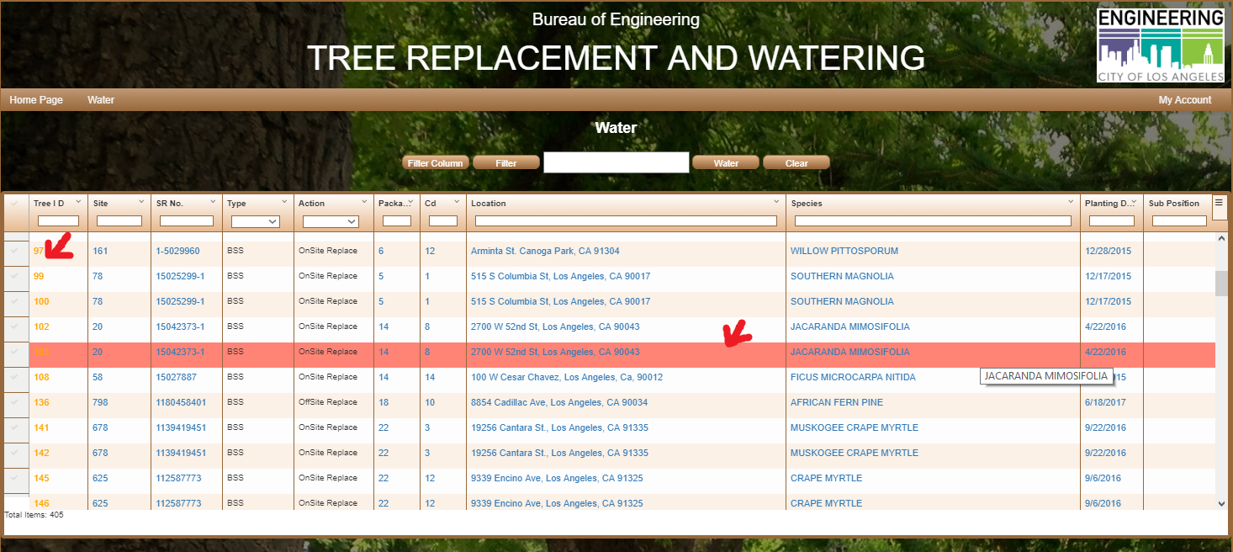

1. Choose date for current watering date field, click save button at the right bottom corner( see red circle)

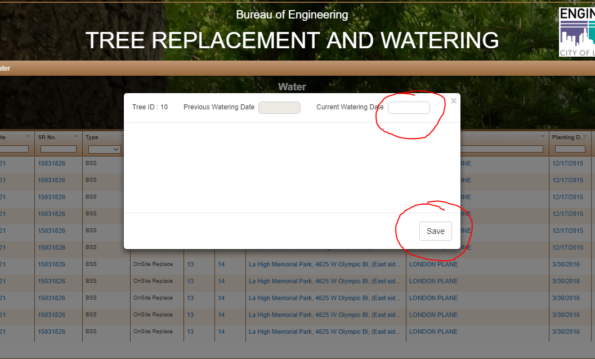

1. How to edit multiple tree water date?
2. Select multiple tree or use filter by column ( see left side bar blue circle)
3. Click the water button to open up the water editing page (see blue circle )

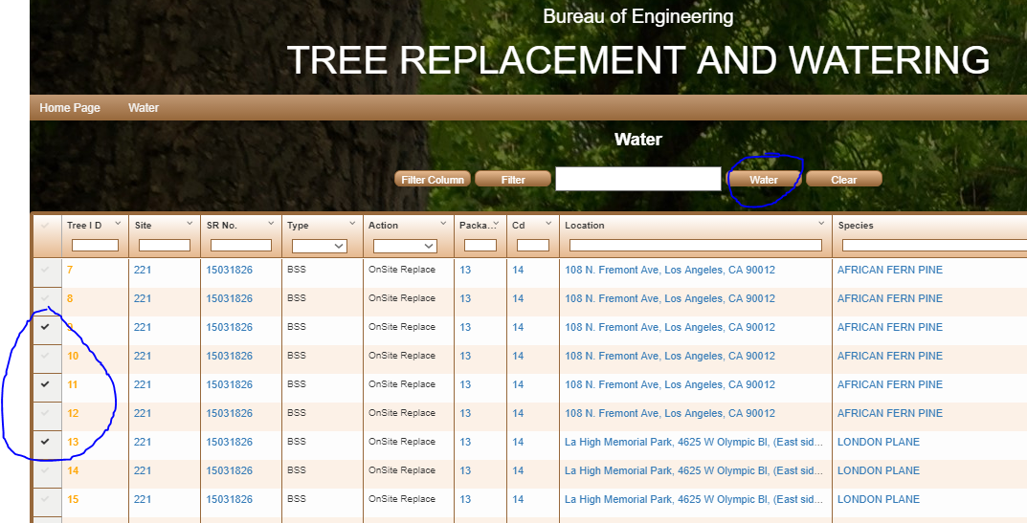

1. On water editing page, click and choose date, it will fill in date for all tree

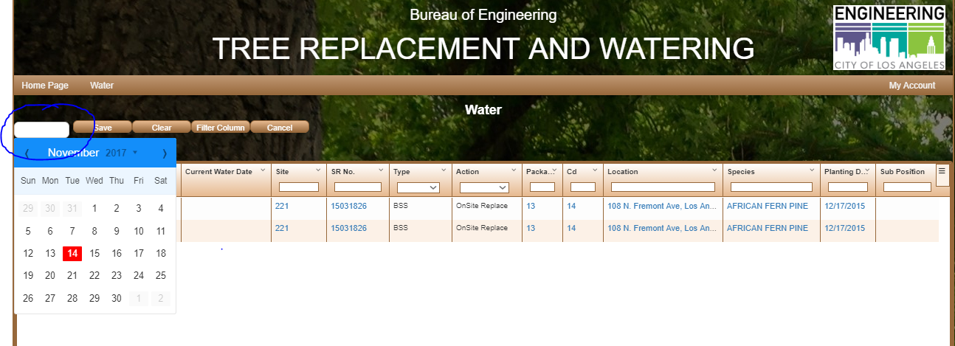

1. On water editing page, you can update each individual tree by double click the field that you want to change and click drop down arrow to open calendar, type or choose the date.

Then click save button.

